[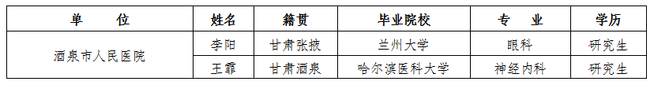](http://www.jqrs.gov.cn/Article/UploadFiles_8382/201712/2017122811325478.png)