[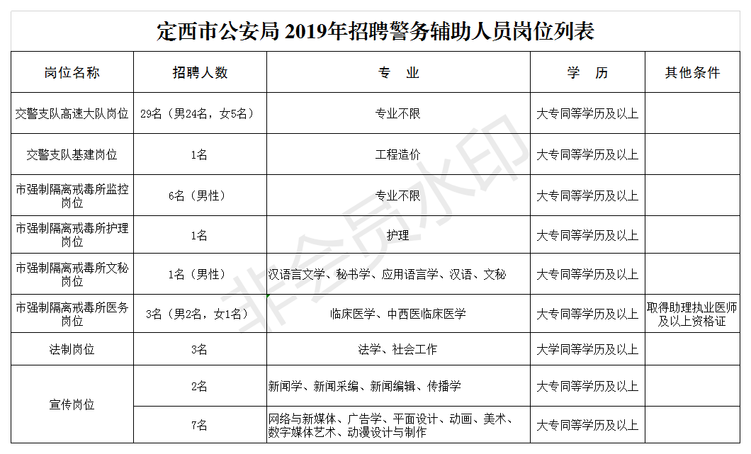](http://zwgk.dingxi.gov.cn/picture/0/02a4f876b5ac4c3eb2c0499ea385f441.png)